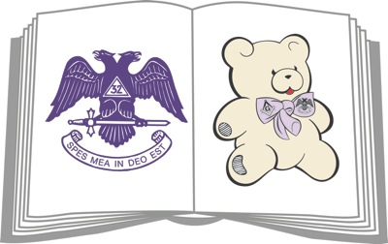

October 5th - Walk - A - Thon for Dyslexia Awareness
at the Scottish Rite in Belleville

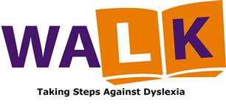

October 20th- Milstadt Chili Cook Off
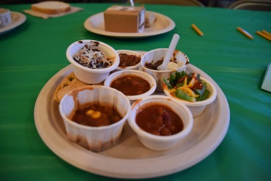

December 7th - Winter Wonderland - Vendor Fair
at the Scottish Rite in Belleville
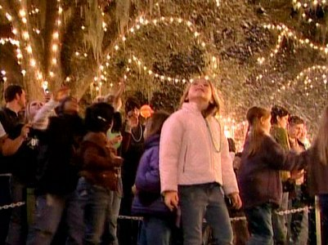

For more information Website www.readwithdyslexia.com
Face Book Children’s Dyslexia Center Southern Illinois

