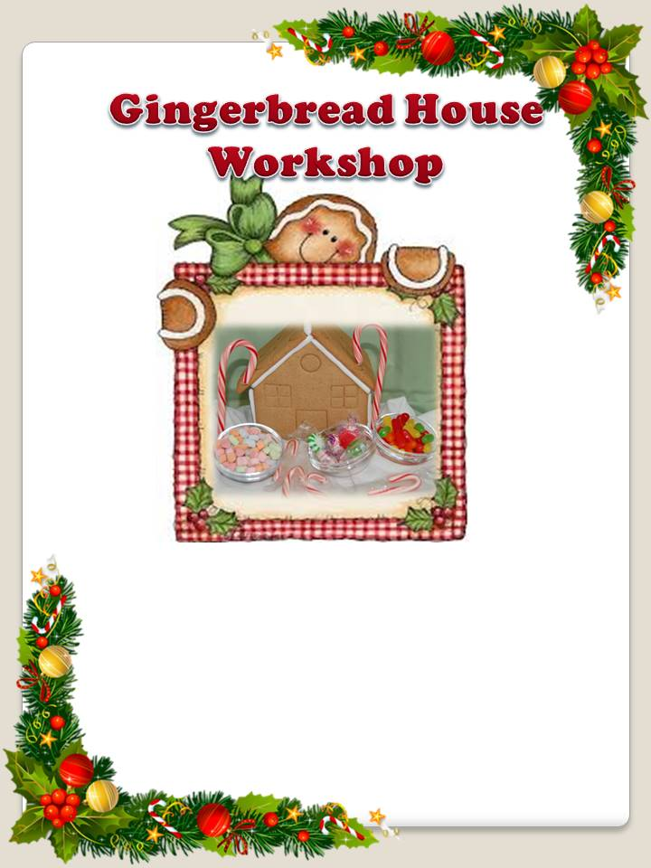

**Pre-Registration Required**

**Call/Text/Email: Jessica Darling**

**618-409-1707**

**Jrchicago23@ hotmail.com**

**$35/ Family**

**All decorating supplies and directions provided!**

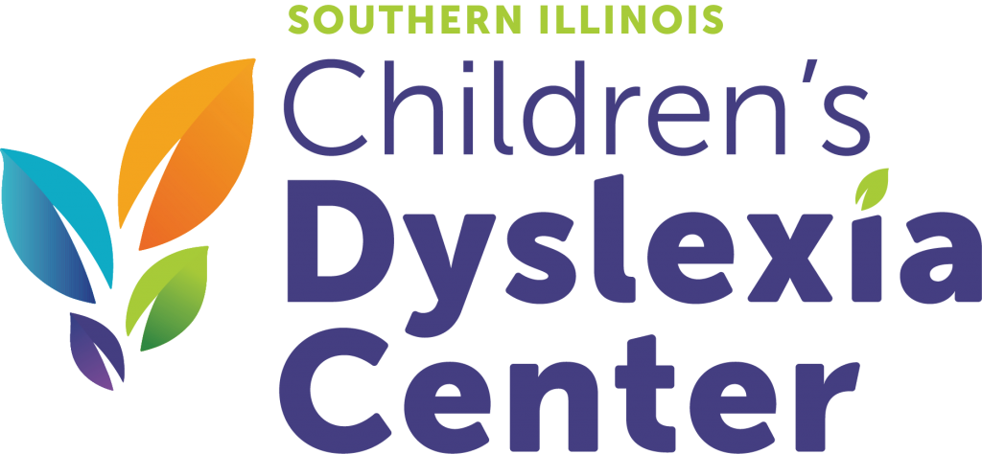

**Proceeds to Benefit:**

**Saturday, November 30, 2019**

**1pm to 3pm**

**Scottish Rite Building**

**1549 Frank Scott Parkway**

**Belleville, IL 62223**